Northboro Junior Woman's Club
45th Annual
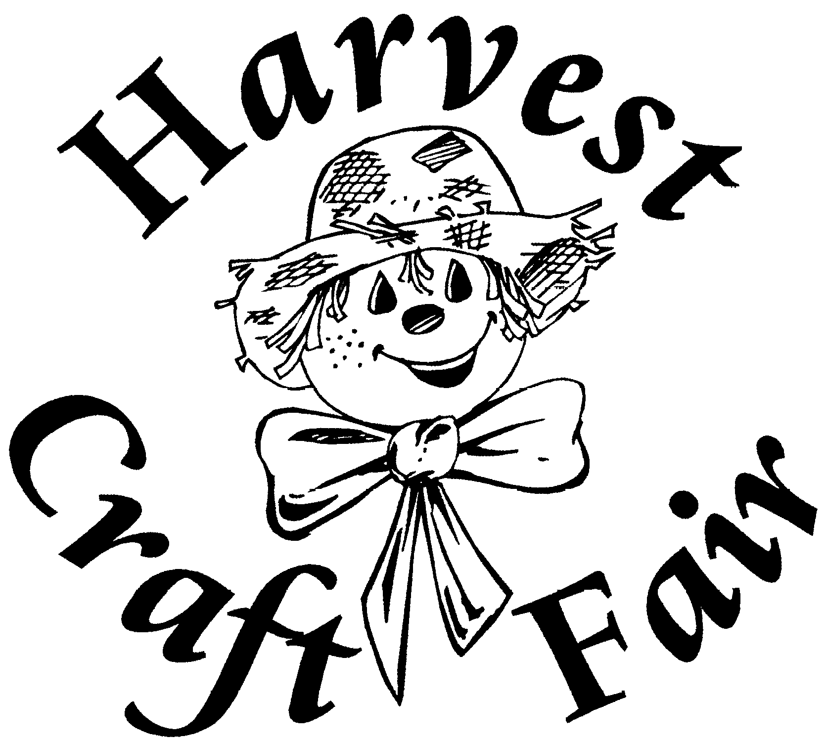

Saturday • November 5, 2022
9 am – 3 pm
Robert E. Melican Middle School
Lincoln Street (off Route 20)
Over 70 Juried New England Crafters

Admission: Adults $4; Seniors $2.50; Children under 12 Free
$1 Off Admission With This Coupon
florals • pottery • soaps • baskets • quilts • ornaments • wood • jewelry specialty foods • clothing • photography • glass • seasonal crafts

